Day 2:

Object : object is any real world entity.

Person

Bank

Animal

Customer

Employee

Property -🡪 have --🡪 variables, fields etc

Behaviour -🡪do/does 🡪 function / methods

In JS object mainly divided into 2 types.

User defined object

Pre defined or built in objects.

BOM and DOM

Browser Object Model

Document Object model

Object -🡪 property

Behaviour

Object --🡪 property

Behaviour

Object -🡪 property

Behaviour

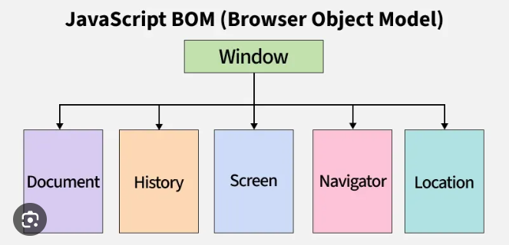

Document is object.

DOM Parser : JS, Python, Java, C# these all language provide lot pre defined function or methods which help to read, write and update dom dynamically.

In JS we can create user defined object using

1. Literal style ES5 JSON : JavaScript Object Notation.
2. Function style ES5 React JS
3. Class style ES6 Angular class style

TypeScript

Literal style : property key not mandatory contains inside double quote. But in JSON property key must in double quote.